Name: Pranali Sonawane
Subject: MCSA
Date: 16-12-2025
Lab 13: Child Domain

Server 2:
Dashboard Add role and Feature next Select DNS and Active Directory Domain Services Automatically Select Group Policy install Restart
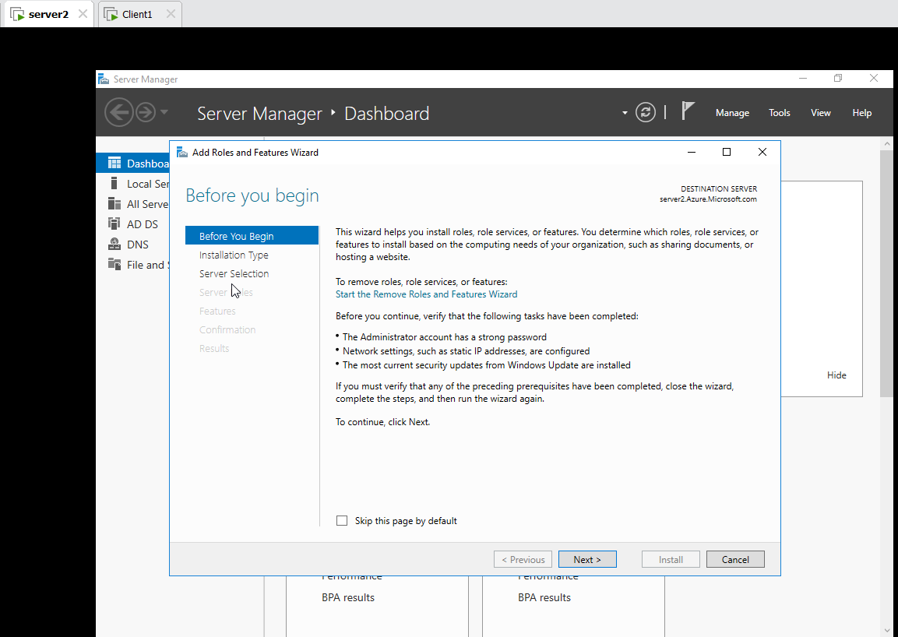
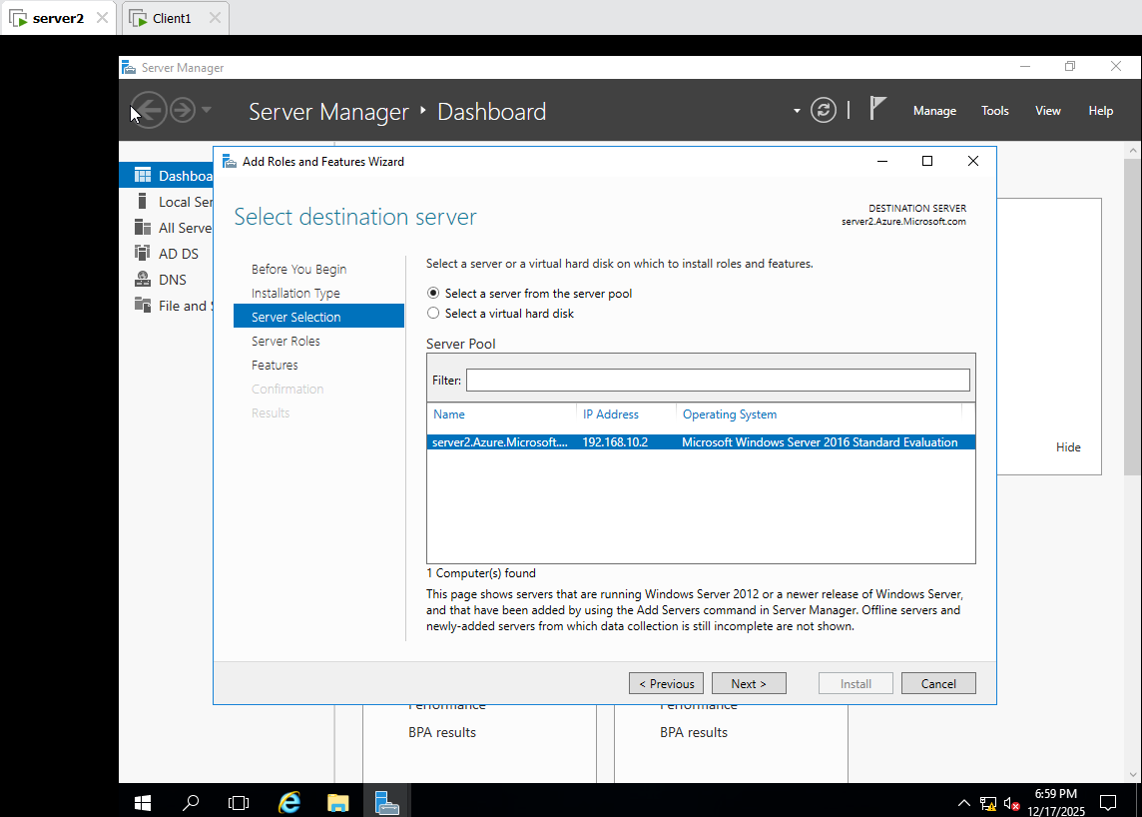

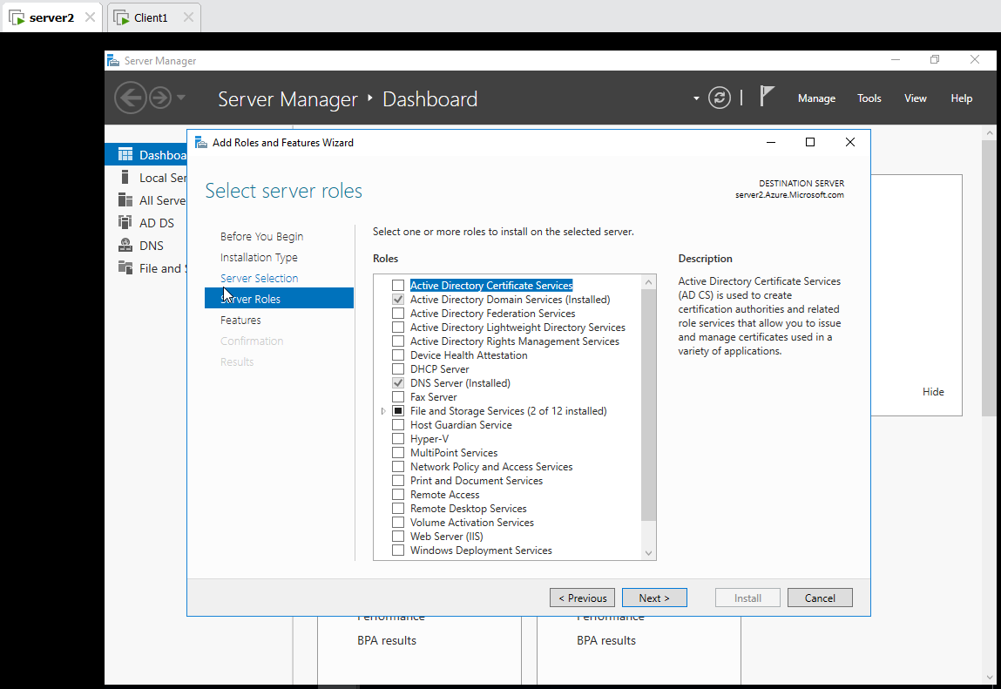
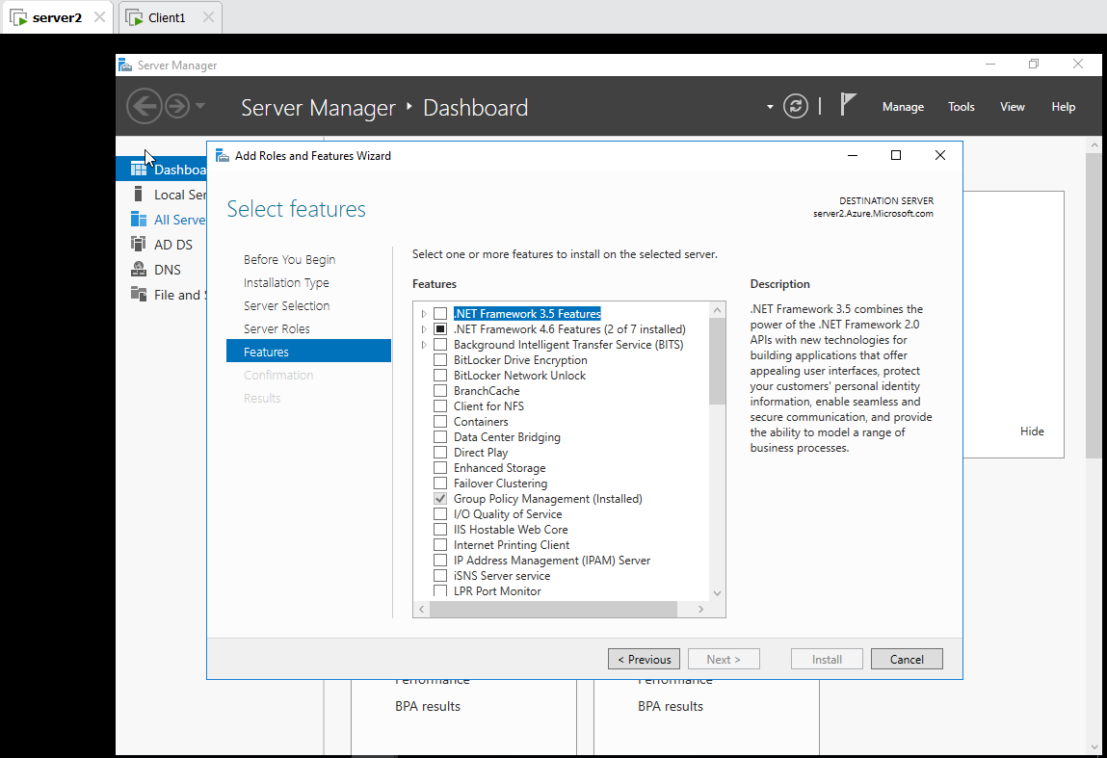
Promote Add new domain to exiting Forest new Domain Azure Password:Password@123 NetBIOS (AZURE) next next install

Sign in : Azure \Administrator
Password@123
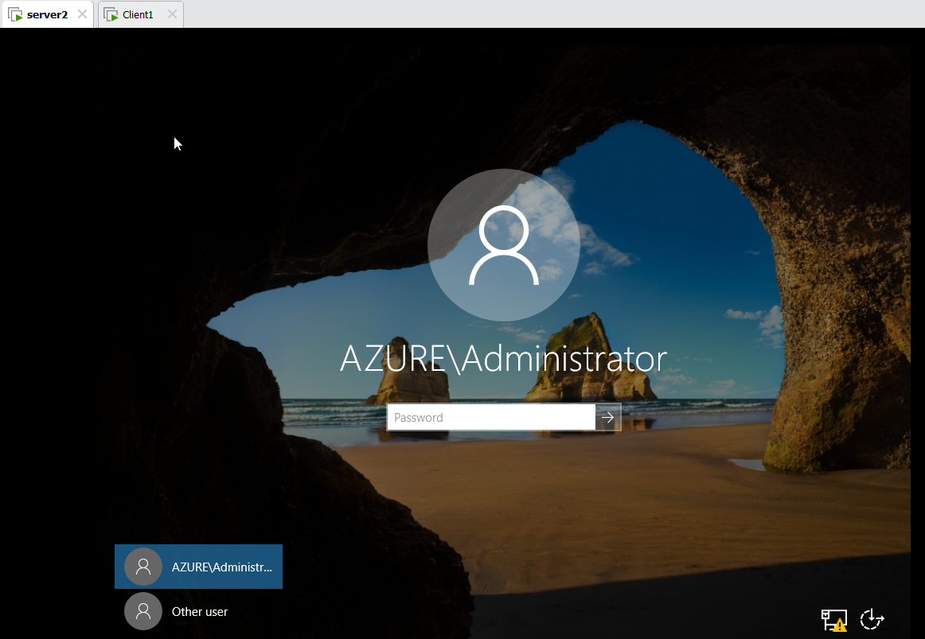
Server2 :
Local Server Ethernet0
Preferred DNS Server: 192.168.10.2
Alternate DNS Server: 192.168.10.1
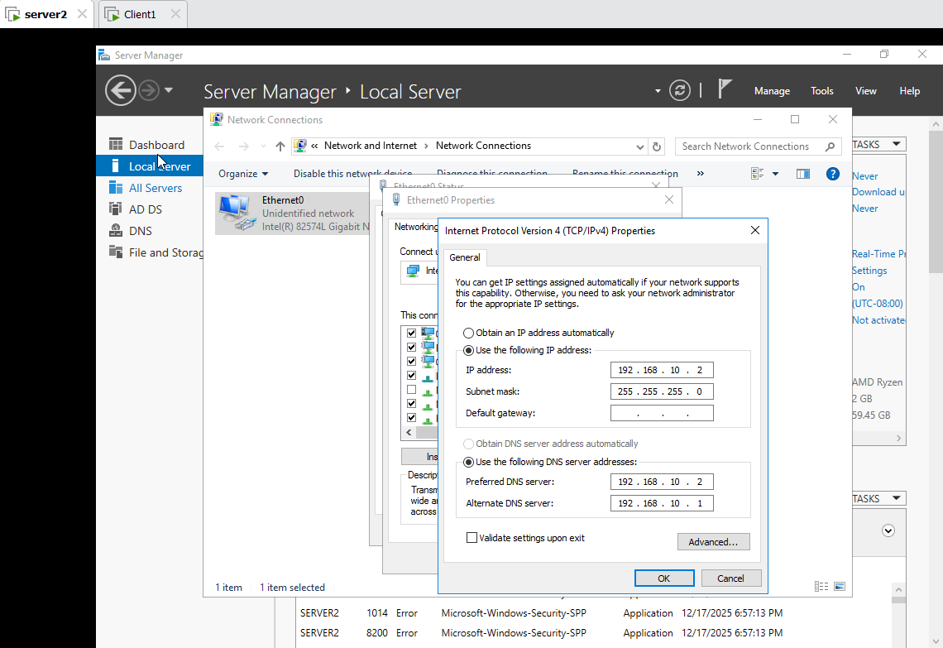
Tool Active Directory Users and Computers Change Domain Select Azure.Microsoft.com ok
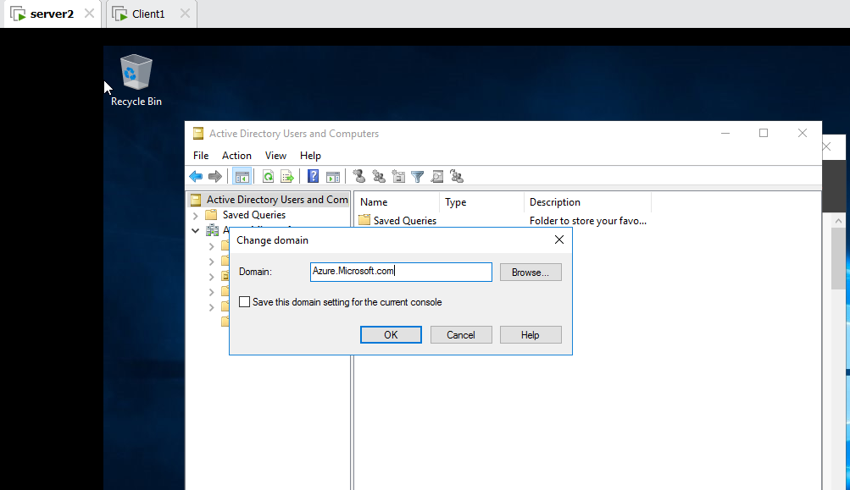
In Server 1:
Tool Active Directory Users and Computers
Computer only server2 is Present
Domain Controller only Server1 is Present

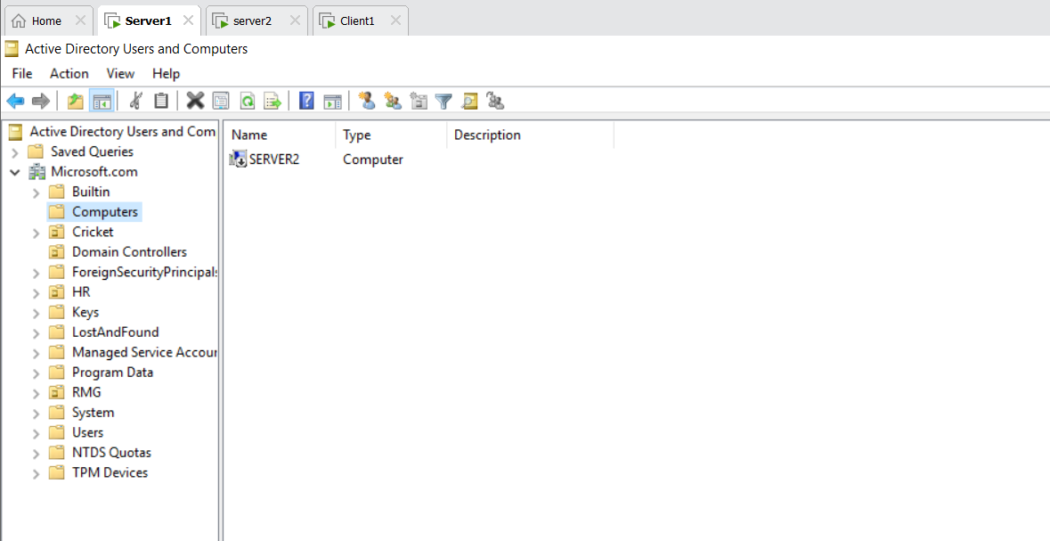

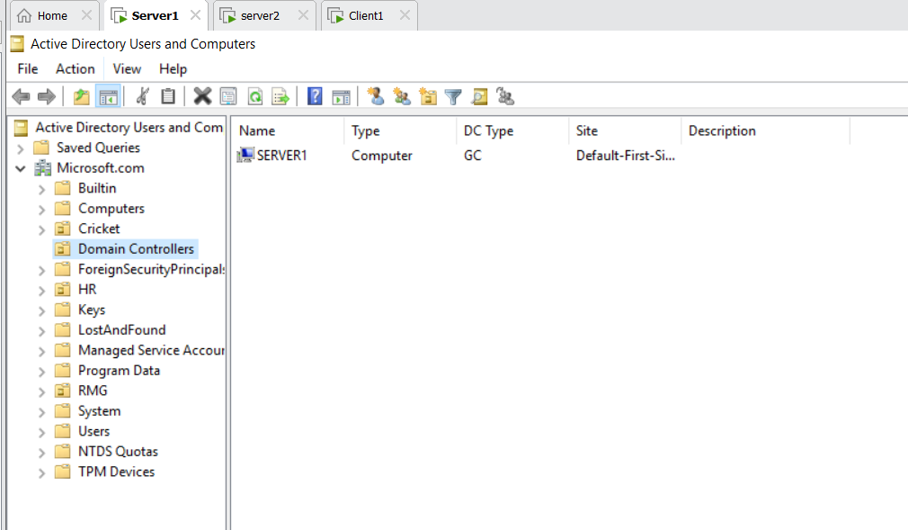

Server 2:
Tool Active Directory Users and Computers Present Azure.Microsoft.com User create a User (Rock)
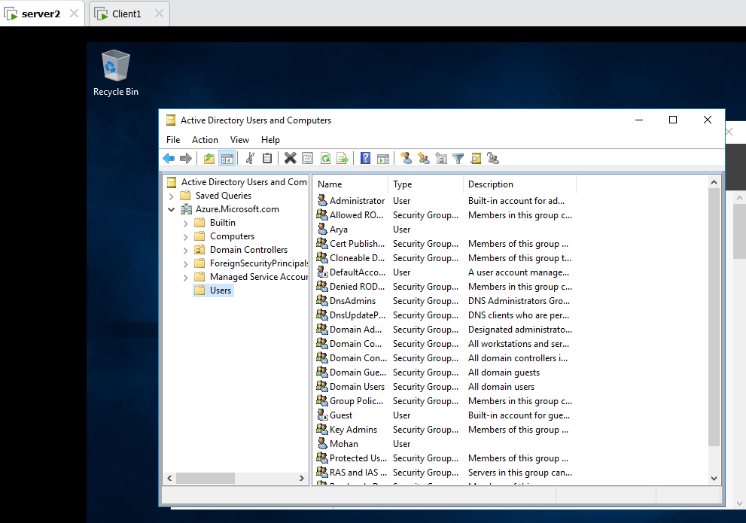
Client 1: Login on Rock
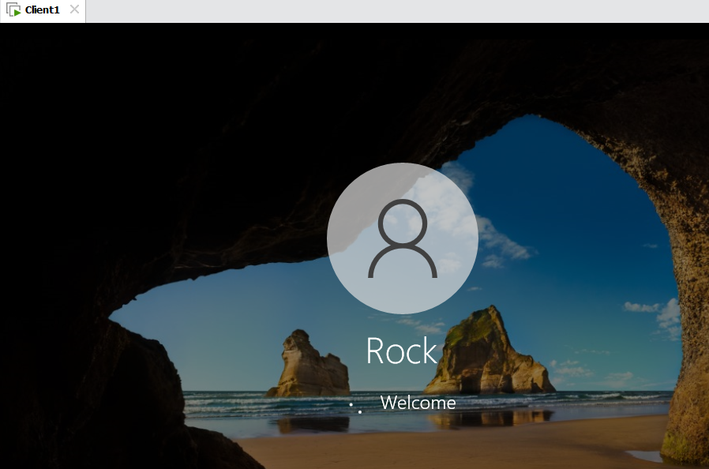
Task :
S2: Domain Azure/Microsoft
C1: Domain Microsoft
Give Task on C1 has Azure/Microsoft

Client 1:
Setting System About Advanced System Settings Change Give Workgroup (W) restart.

Setting System About Advanced System Settings Change Domain Name Azure.Microsoft.com ok

Also Check Server 2:
Tool Active Directory Users and Computers
Computer only Client1 is Present
Domain Controller only Server2 is Present
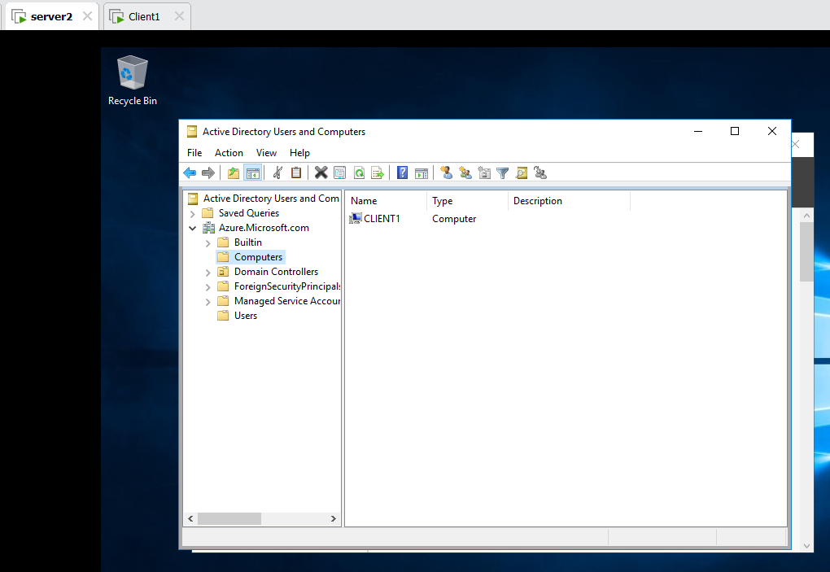
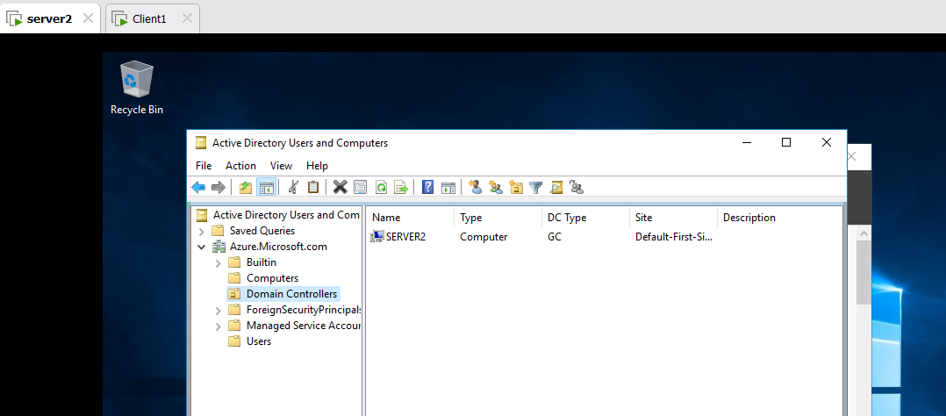

Client 1:
Run ncpa.cpl Ethernet0
Preferred DNS Server: 192.168.10.2
Alternate DNS Server: 192.168.10.1
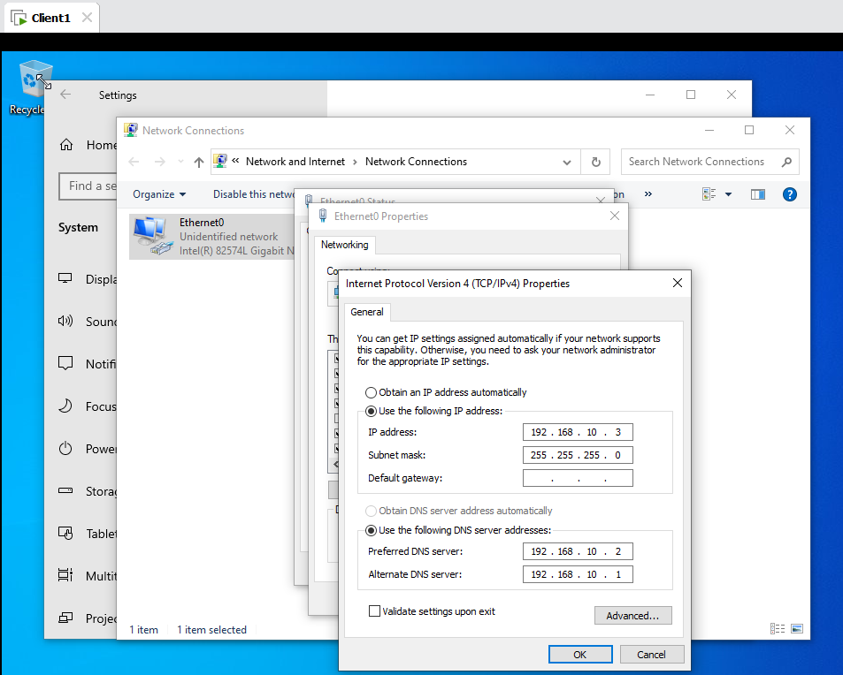

Client 1:Login Azure\Administrator
